In order to examine the relationship between a student’s lifestyle and gender versus their awareness, perception, and purchase intention of Lululemon, we asked the participants of the survey for their gender and to list how many hours were they active in week. We came up with five hypothesizes ${(H}_{a})$:

1. Purchasing Lululemon in the past will result in higher awareness, perception, and purchase intention of Lululemon
2. The more hours active, the higher awareness a person will have of Lululemon
3. Being on a UBC Sports team also means that they will have a higher awareness for Lululemon
4. Females will have a higher awareness, perception, and purchase intention of Lululemon than males
5. The more money spent on active wear will result in a higher purchase intention of Lululemon

We examined 5 independent variables in relation to Lululemon. Those variables being: Gender, whether they have purchased Lululemon before, if they participate in a UBC sports team, hours active in a week, and the amount of money spent on active wear. In order to run the regression on SPSS we first created dummy variables. Looking at Figure 1, 2, and 3 each category is separated into numbers ranging from 1 to 4. Generally, the closer the number is to 4 the higher the value—excluding nominal classification: gender, being on a sports team or not, etc. For example, for money spent in a month, we split it into 4 categories assigning each from a number from 1-4 in the following order: 100-250, 251-500, 501-1000, and 1000+ (please refer to Figure 4 for every value classification used to create dummy variables)

First, we examined the relationship between purchasing Lululemon versus the overall attitude (awareness, perception, and purchase intention of Lululemon) towards Lululemon. All three characteristics showed values that would lead to the conclusion that we should reject the null hypothesis ($H_{0}$) and accept ${(H}_{a})$. The data (Figure 5, 6, and 7) shows high strength in the regression as well as a high significance in the data. For example, the relationship between someone buying Lululemon before versus their overall purchase intention of Lululemon (Figure 5) has values that would support this conclusion. Here we can see a high $R^{2}$ value of 38%, meaning that 38% of the variable $x$ (buying Lululemon before can be explain by variation in $y$ (purchase intention of Lululemon). For example, when looking at awareness (Figure 5) for every 1 unit of Lululemon that is bought, awareness increases by 0.189. In addition, the Durbin Watson is between 1-3, the data points are along the PP line, and the significance is < 0.01. However, the residual statistics (Figure 8) shows values between -3.695 to 2.013, meaning there is a heteroscedasticity in the data—meaning the data is a bit scattered. But overall, the data shows that there is a strong correlation between purchasing Lululemon before and purchase intention of Lululemon.

Next, we examined the relationship between hours active in a day with the Lululemon’s awareness. Our hypothesis is that the more hours spend active in week, the higher the awareness people will have with Lululemon. However, our results indicate that we need to fail to reject ($H_{0}$). The data (Figure 9 and 10) shows a low $R^{2}$ value of 8.4%, significance values of over 0.05, and heteroscedasticity. The means (Figure 11) also suggest that the variance is too high for hours “2-5” and “5+”. However, the one silver lining is that for “less than 2 hours and under” the significance value is 0.42, meaning that the data for “less than 2 hours and under” has a small impact on the purchase intention of Lululemon. The data results indicate that spending more than 2 hours active in a week will not impact purchase intention of Lululemon and that we will fail to reject ($H_{0}$).

We will then examine whether females have a higher awareness, perception, and purchase intention of Lululemon than males. This is because Lululemon’s advertisements tend to gear towards a female audience. We want to see if this is true in UBC. For purchasing intention, it passes the Durbin Watson, a decent $R^{2}$ value of 0.085, and a significance of less than 0.05 (Figure 12). This means that the table is more or less accurate and suggests that females have a higher awareness of around 0.088 compared to males (Figure 12). For perception, the data shows a lower $R^{2}$ value of 0.028, a high significance value of 0.167, and passes the Durbin Watson test (Figure 13). Because the significance value is higher than 0.05, we will fail to reject ($H_{0}$) because we cannot prove that females have a higher change in $x$ than males. Awareness is similar but the $R^{2}$ value is much lower at a 0.005 (Figure 14) and therefore we can arrive at the same conclusion as we did with perception and say that we will fail to reject ($H_{0}$) because we cannot prove that females have a higher change in $x$ than males. However, because purchasing intention is a combination of both awareness and perception, we can overall reject the ($H_{0}$) and accept ${(H}_{a})$ if we are analyzing Lululemon solely based off of the purchase intention of females versus males.

Finally, we examined the relationship between money spent on active wear and its impact on the purchasing intention of Lululemon to determine if customers value our brand as a luxury product. Both data tables indicate that the average money spent on sports wear in a month has no impact on purchasing intention of Lululemon (Figure 15 and 16). Whether the data is in reference to spending 100-200 or more than 1000, the data shows a low $R^{2}$ value of 0.065 and if we were to refer to the adjusted $R^{2}$ (because we are comparing multiple independent variables) it is 0.005. The significant values of every selection are all above 0.05 and therefore suggests that the data shown is not significant. If we were to refer to the mean (Figure 17) we can see that there is high variation between every selection—and just like when we examined the hours spent active in a week—it suggests that money spent has no impact on the purchase intension of Lululemon products. Therefore, we fail to reject ($H_{0}$).

Appendix

**Figure 1**

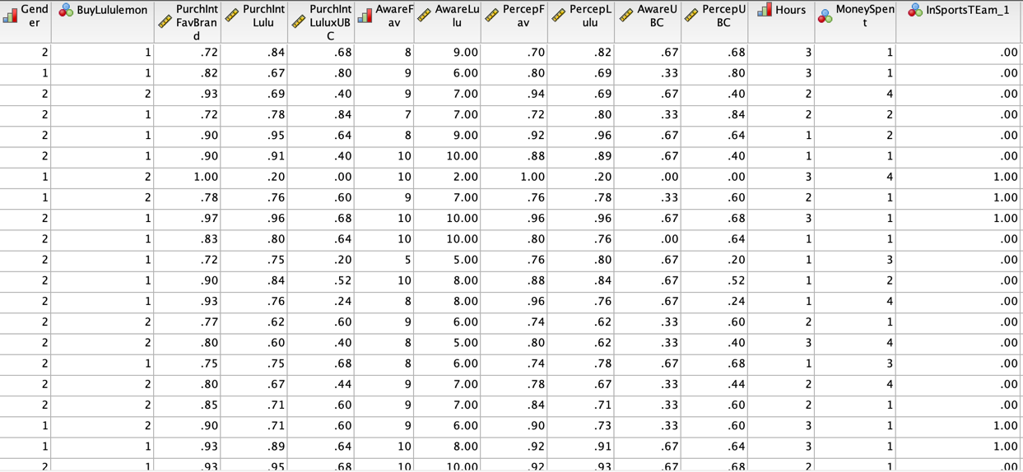

Figure 2

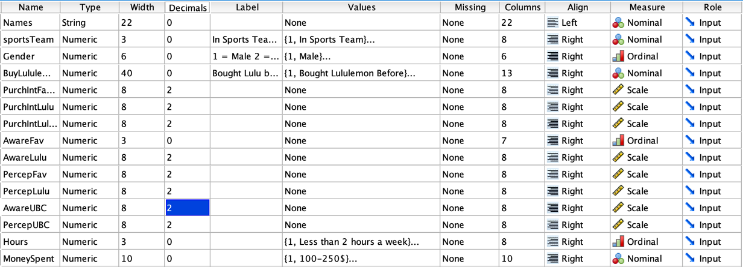

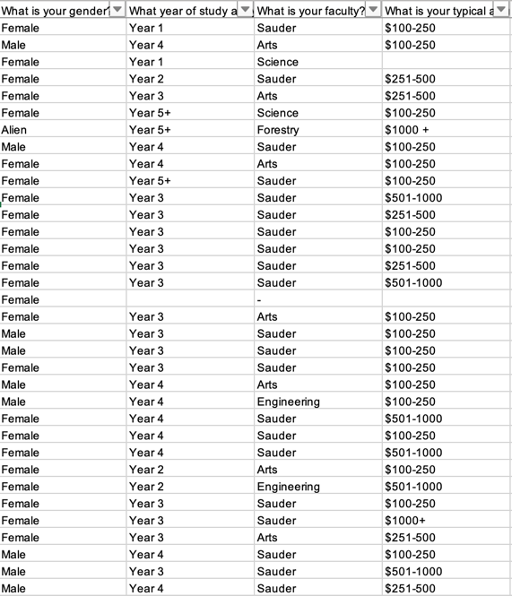Figure 3

Figure 4